**Fires**

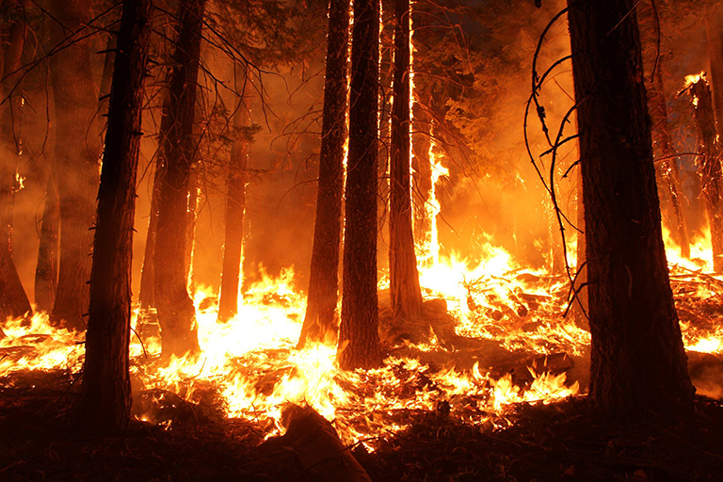

The 2013 Rim fire in and near Yosemite National Park. Credit: USFS/Mike McMillan

<https://climate.nasa.gov/blog/2830/six-trends-to-know-about-fire-season-in-the-western-us/>

**Floods**

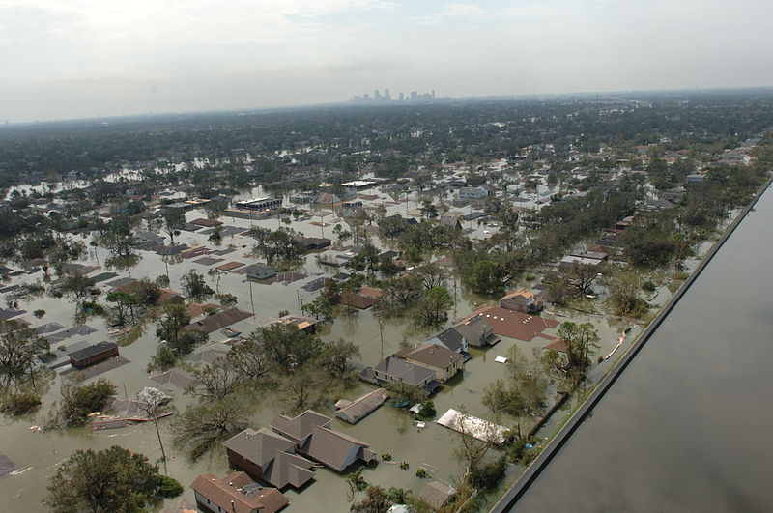

Credits: FEMA / Jocelyn Augustino

<https://commons.wikimedia.org/wiki/File:FEMA_-_18169_-_Photograph_by_Jocelyn_Augustino_taken_on_08-30-2005_in_Louisiana.jpg>

**Earthquakes**

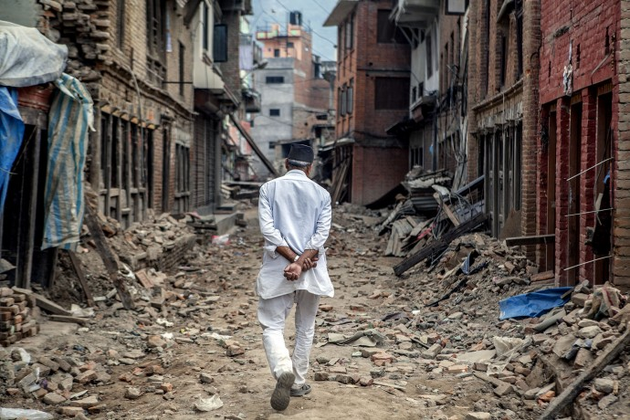

Credits: Kadish Das Shrestha, USAID

<https://blog.usaid.gov/2016/04/the-real-heroes-behind-usaids-nepal-earthquake-response/>

**Hurricanes & Cyclones**

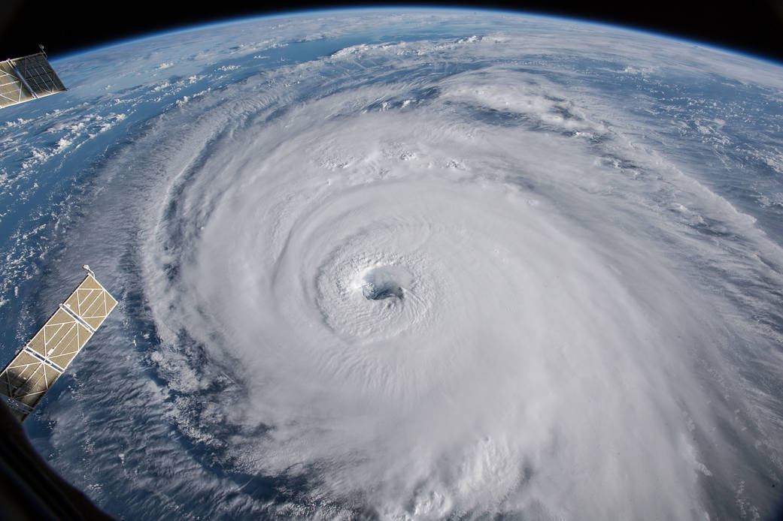  
Credits: NASA

<https://www.nasa.gov/image-feature/hurricane-florence-1>

**Volcanoes**

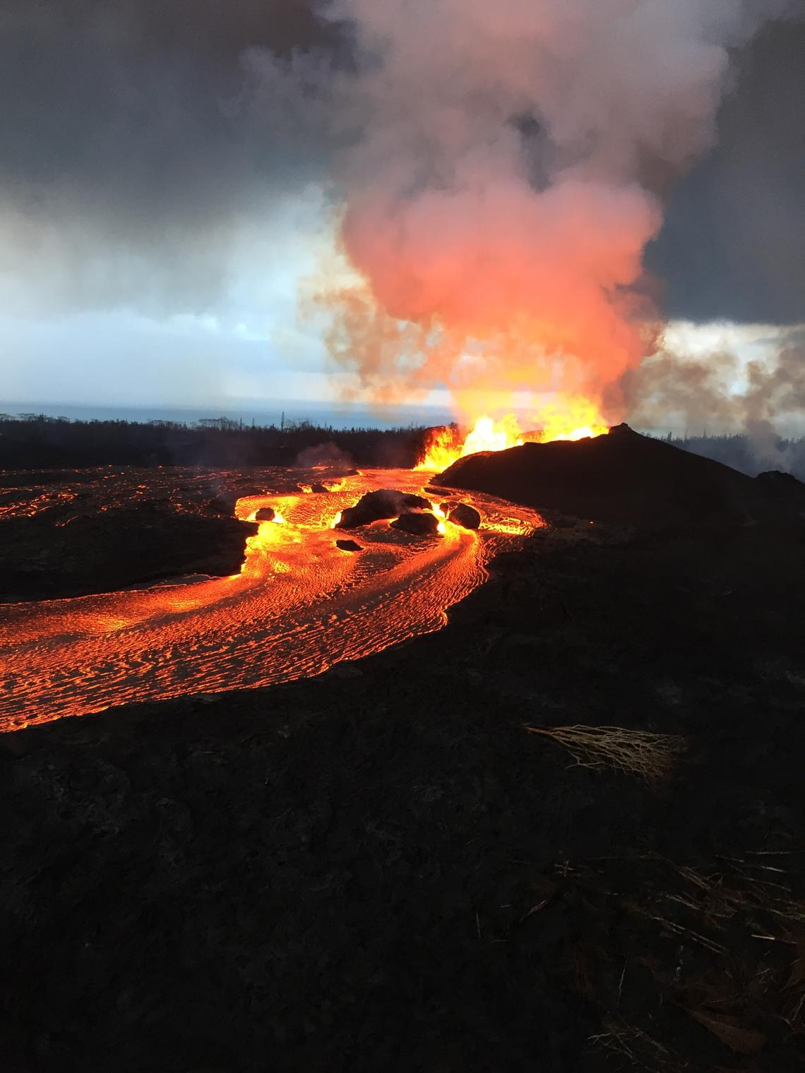

Credits: J.D. Griggs, U.S. Department of Interior, U.S. Geological Survey.

<https://exoplanets.nasa.gov/news/196/seeking-life-on-other-worlds-check-for-volcanoes/>

**Landslides**

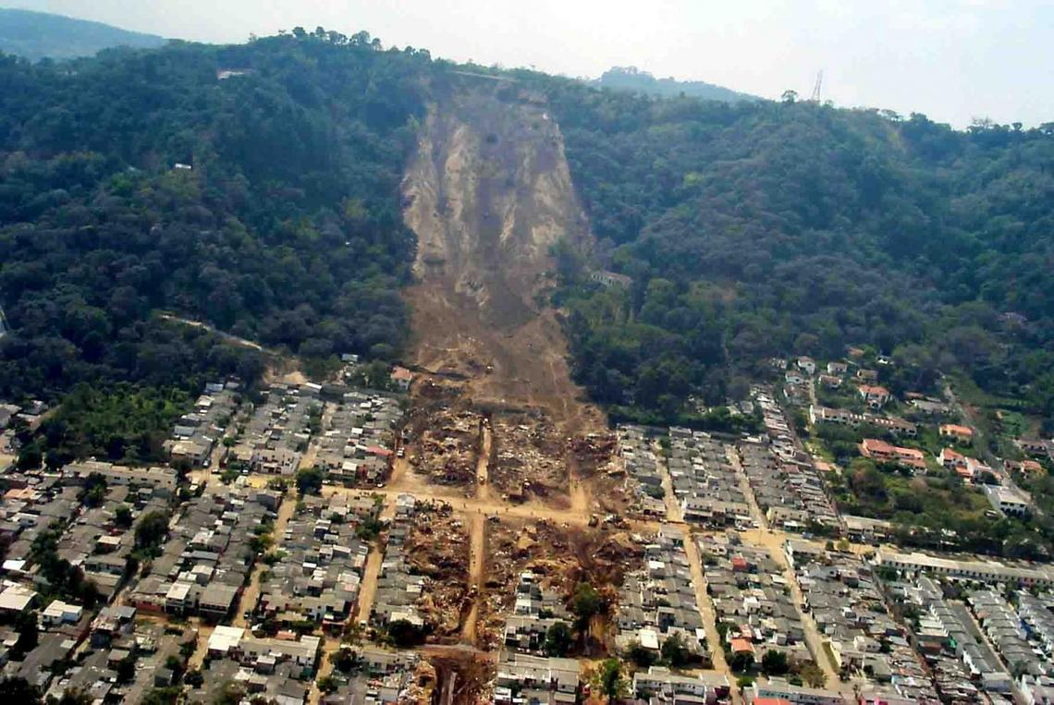

Credits: USGS

<https://www.usgs.gov/media/images/el-salvador-landslide>

**Industrial Accidents**

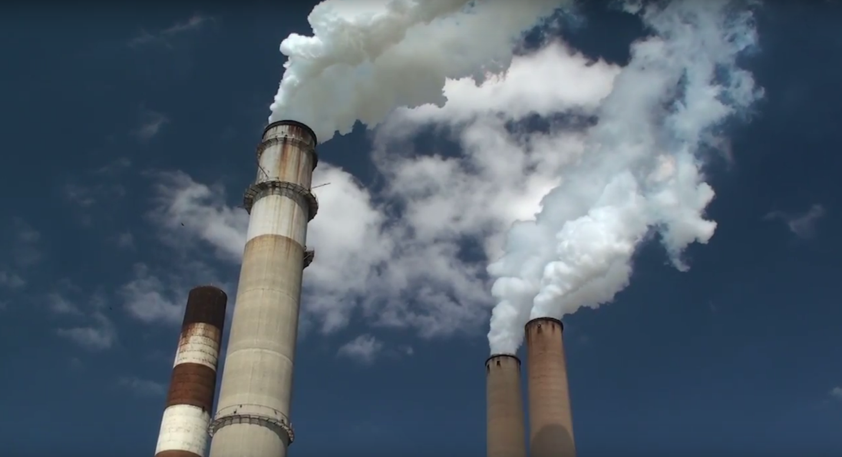

Credits: NASA

<https://www.nasa.gov/press-release/new-nasa-satellite-maps-show-human-fingerprint-on-global-air-quality>

**Severe & Winter Weather**

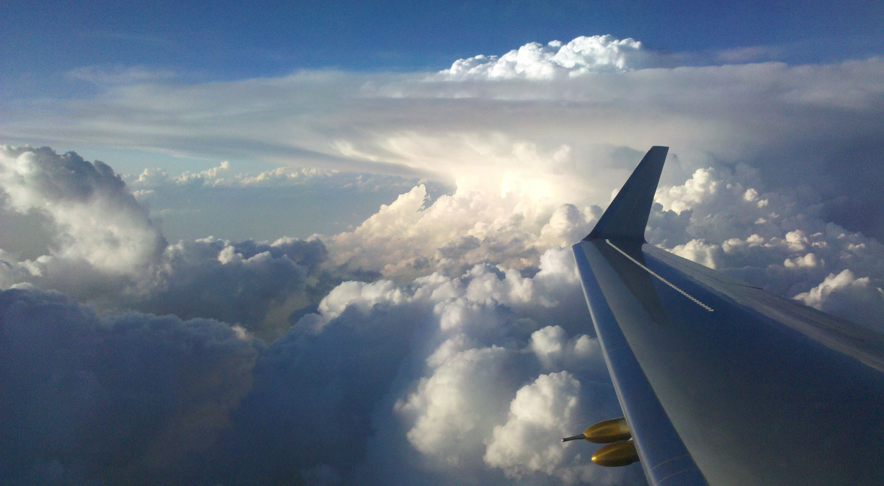

Credits: NASA

<https://www.nasa.gov/specials/nasalangley100/project11.html>

**ISS Imagery**

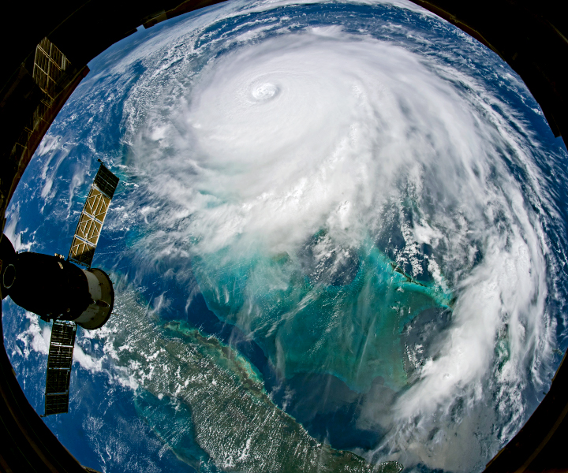

Credits: NASA

<https://earthobservatory.nasa.gov/images/145559/a-devastating-stall-by-hurricane-dorian>

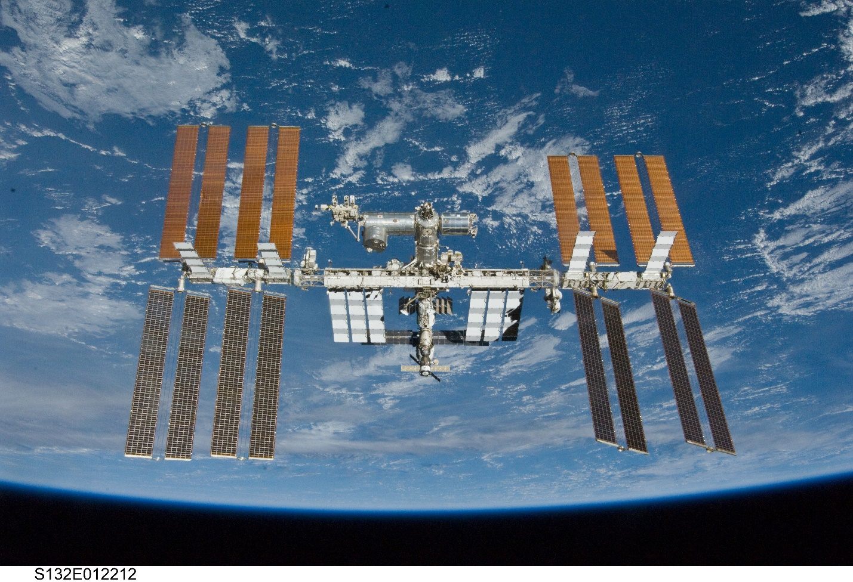

Credits: NASA

<https://www.nasa.gov/feature/the-international-space-station-is-a-unique-place>

**Risk Reduction**

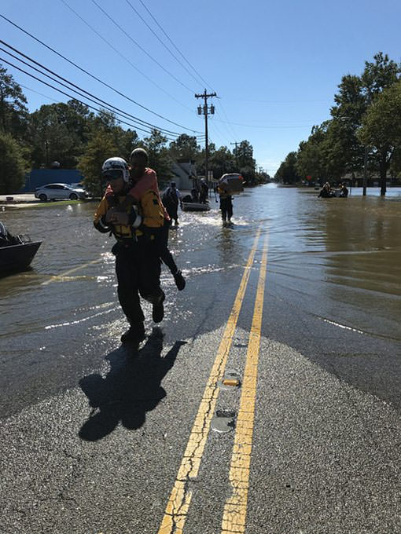

Credits: FEMA

<https://appliedsciences.nasa.gov/our-impact/story/easing-hurricane-matthews-misery>

**Near Real-time Products**

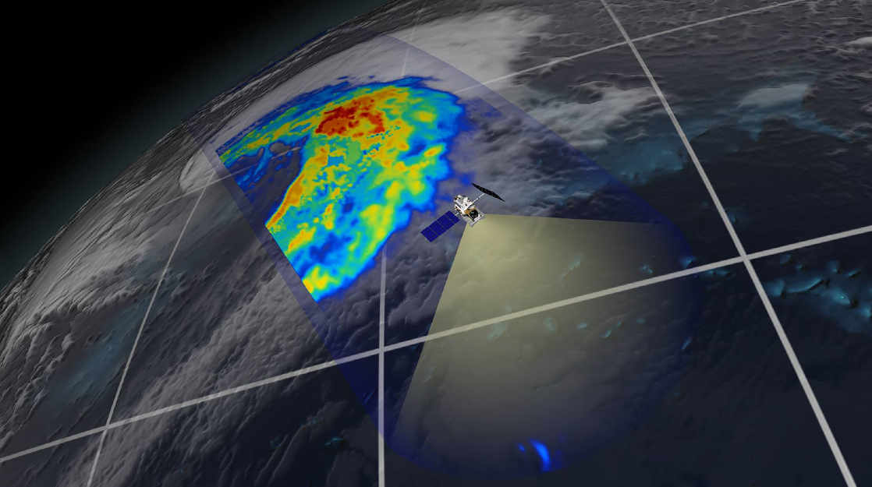

Credits: NASA

<https://www.nasa.gov/mission_pages/GPM/main/index.html>

**External Resources**

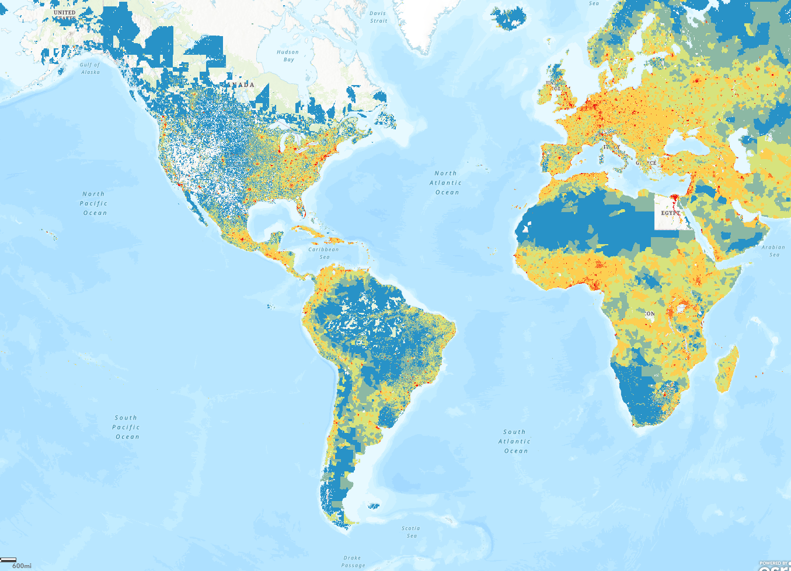

Credits: NASA

<https://maps.disasters.nasa.gov/arcgis/home/webmap/viewer.html?useExisting=1&layers=8dc235cf311c45c187a42840f28706c4>